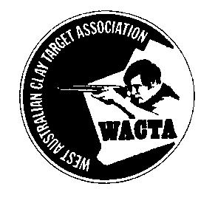
WACTA 5 Stand Sporting
Carnival
13th and 14th June 2020
Held at Whiteman Park International Shooting Complex (WAGC)
Saturday 13th June

9:00am start
Event 1 50 Tgt 5 Stand Sporting Competition
Event 2 50 Tgt 5 Stand Sporting Challenge Cup
Sunday 14th June

9:00am start
Event 3 100 Tgt 5 Stand Sporting State Title
Carnival High Gun from Events 1,2 and 3
Teams Selection Event 2 and 3
Sunday Night Presentations
For further information contact:
State Secretary: Anita Dyas 0488 777 175
WACTA reserve the right to change the program

